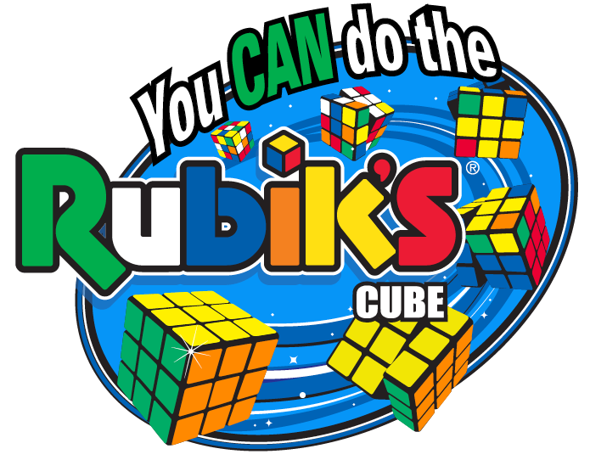 | Northern California  Rubik’s® Cube Competition  at the Humboldt Math Festival  Where: Adorni Center  1011 Waterfront Drive, Eureka, CA 95501  When: Saturday, April 28, 2018  12- 4pm
Questions? Contact: Diana Gettman Flores, dianagettman@rubiks.com
or Jana Reveles, jreveles@fortunaesd.com

The competition will consist of team and solo events. *All teams must be first-year competitors.*
- Teams of 8 students will collectively solve 25 3x3 and/or 25 2x2 Rubik’s Cubes.
- Solo students from registered teams can also choose to compete to solve a 2x2 and/or 3x3 Rubik’s Cube in the fastest time.
Team rosters and solo competitors’ names must be submitted prior to event day. Schools may enter more than one team per school but each team must have a dedicated coach. Click here to review the Eligibility and Tournament Rules (tinyurl.com/RubiksRules)
Registration will close April 6
https://speedleague.youcandothecube.com/web/competition-list.php?competition=104

This competition is open to teams of students from schools in northern California in grades K-12. Teams from surrounding areas, including Oregon, are welcome to join as long as they are a first-year team. Teams will compete in 3 divisions based on the grade level of the oldest team member- Division 1: K-5th grades, Division 2: 6th-8th grades, Division 3: 9th-12 grades.
It's free to register your team and compete. To register, each team must designate a teacher/coach who is over 21 years of age who will be the team contact.
Each team will need to bring a set of 25 Rubik’s brand cubes to the competition:
You CAN Do The Rubik’s Cube provides an Education Kit for purchase or for loan.
Kits can be purchased online using PROMO CODE COMP18 or by downloading this Order Form for $124.99 (12 Cubes) or $199.99 (24 cubes) plus FREE Shipping.
To apply to borrow a set of 25 cubes go to: www.YouCanDoTheCube.com/compset Use Promo Code NCA18 for a set of 3x3 Rubik’s Cubes and/or code 2x2NCA18 for a set of 2x2 Rubik’s Cubes.

About You CAN Do the Rubik's Cube
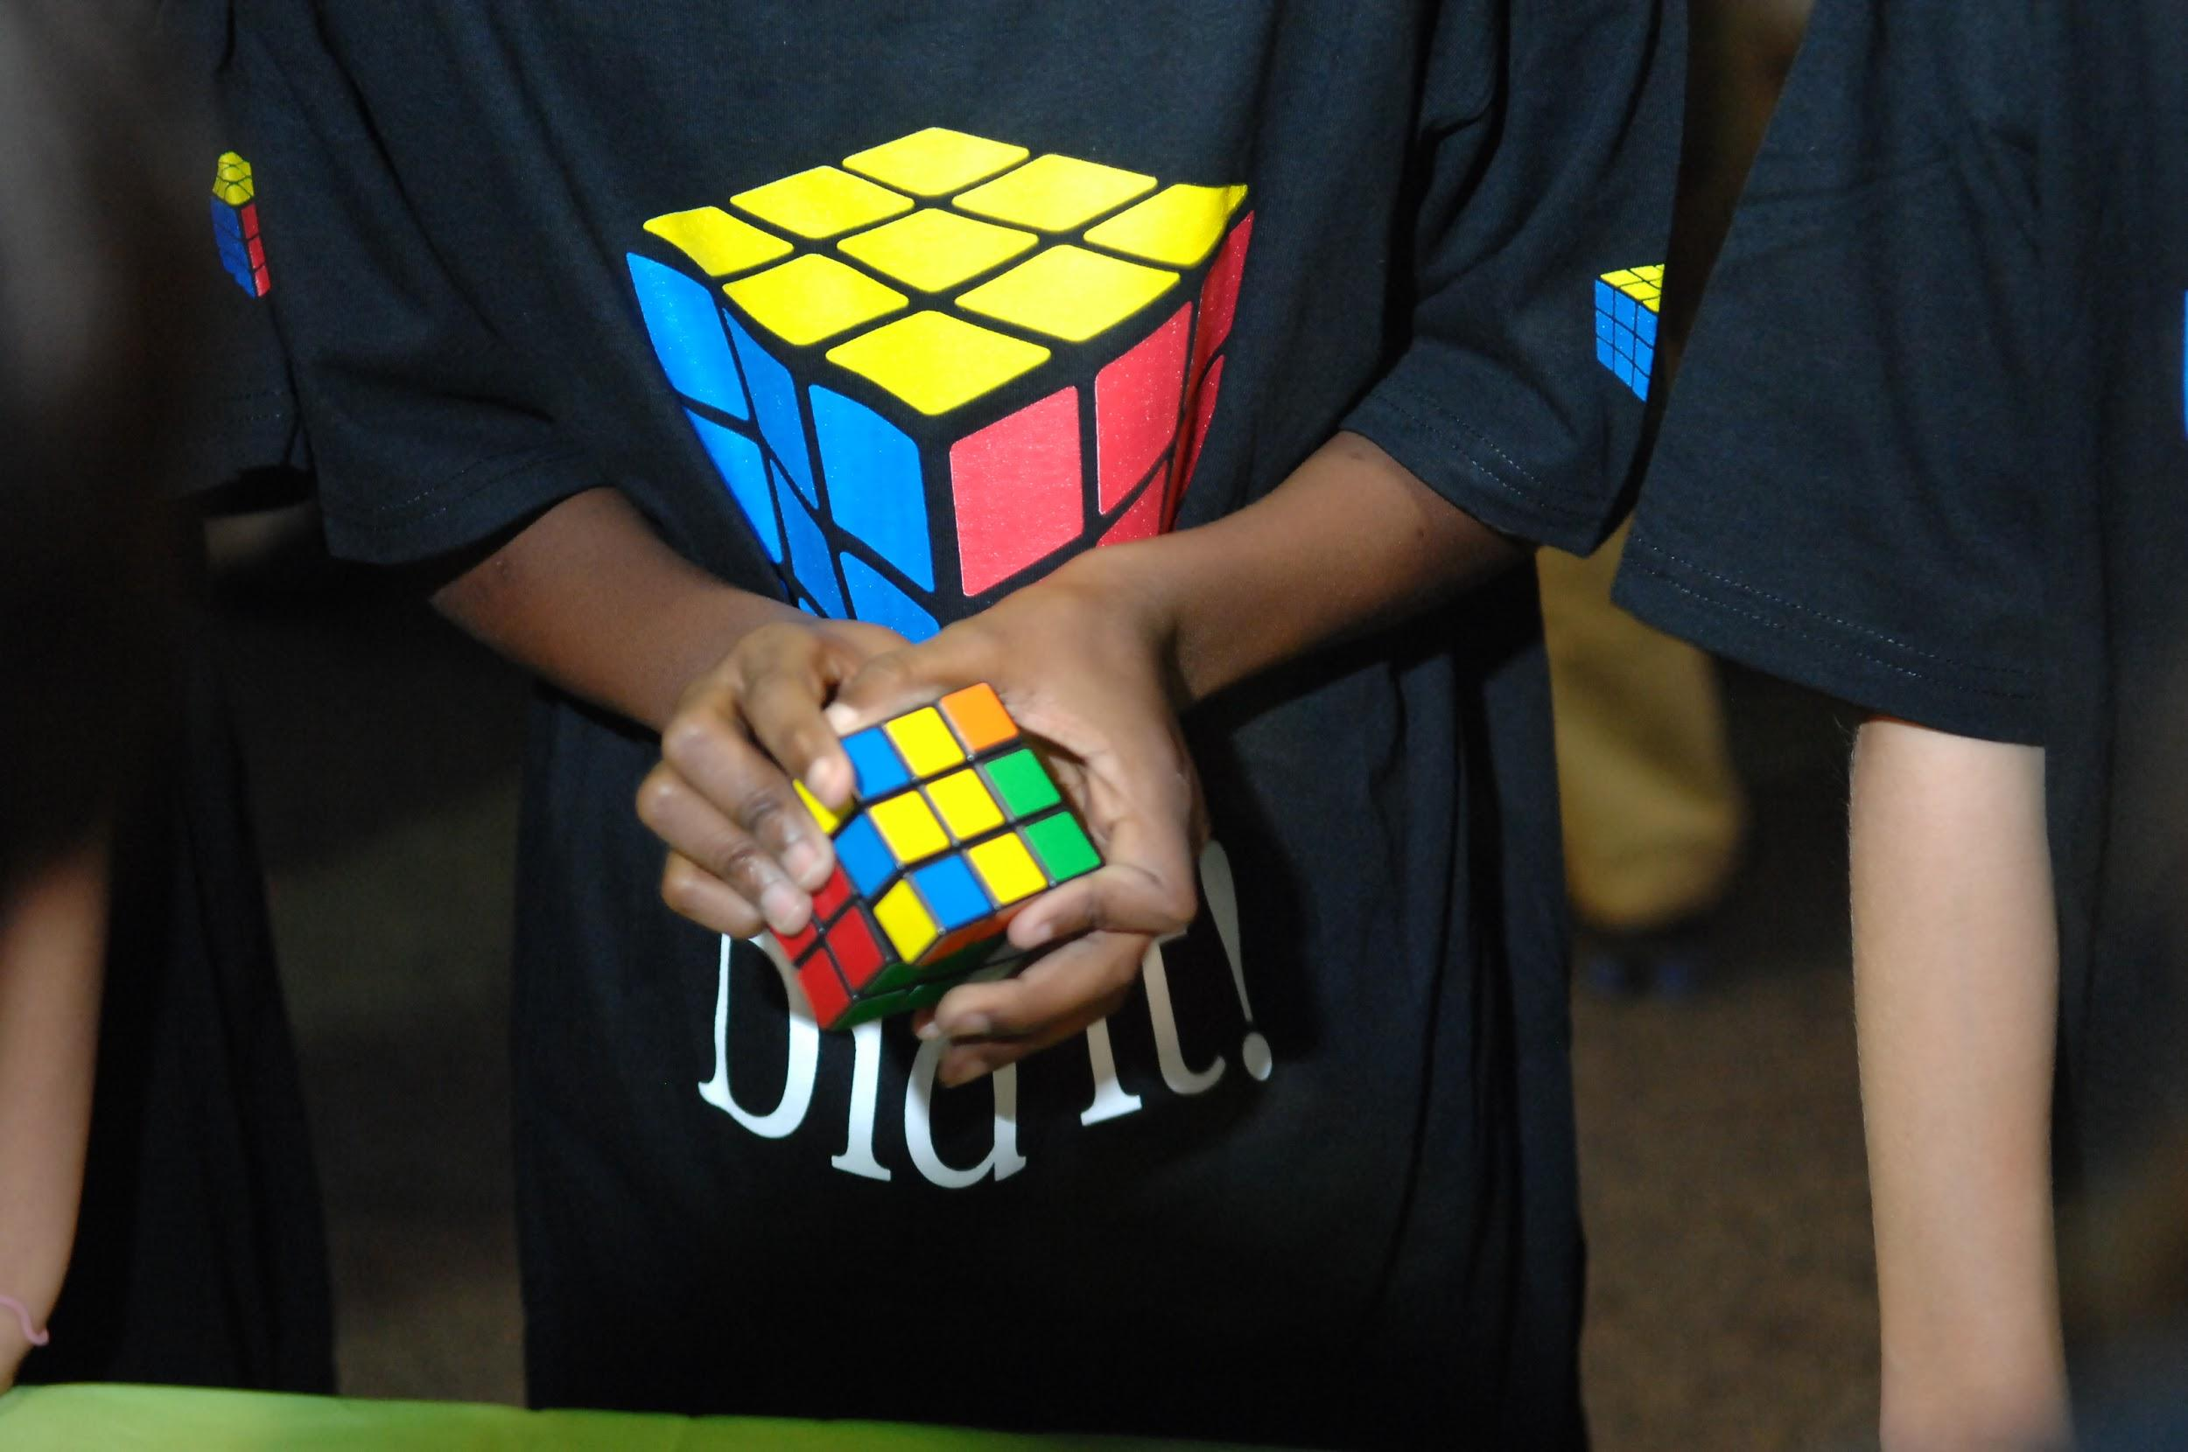
Everyone's favorite puzzle is now used in schools and youth organizations across the country to teach math, science, engineering and art concepts as well as critical thinking and problem solving skills. You CAN Do the Rubik's Cube is an STEM education program that can be integrated into the school curriculum and/or used as an educational outreach activity through after school clubs, community youth organizations or any environment that encourages learning activities. For further information on using the You CAN Do The Rubik's Cube program in your organization, go to: www.YouCanDoTheCube.com
Challenge Checklist
- Register your team
- Read the rules & FAQs
- Buy or borrow 25 cubes
- Practice
- Submit team roster
- Compete and have fun!

