The Sierpinski Tetrahedron Project
Humboldt Math Festival 2018

Sierpenski Triangles are fascinating geometrical shape and a fractal! They have the overall shape of an equilateral triangle, but they show the property of being able to be subdivided into small and smaller triangles, or conversely magnified infinitely. The included design shows how the triangles recursively get smaller and smaller. THEN, the design folds into a tetrahedron, a four sided figure with a equilateral triangle on each side, and THOSE can be put together in classrooms or at the festival to form larger and larger Sierpinski tetrahedrons! It is a great individual and cooperative project.

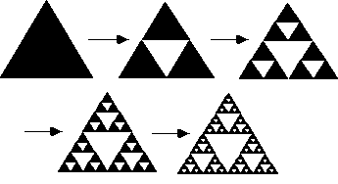
image source: https://math.stackexchange.com
Folding hints: You can assemble your decorated tetrahedron in advance, or bring it flat and put it together at the festival. For easier folding, use a ruler and a ball point pen and draw a heavy line on the folding edges. This scores the paper slightly and makes much better folding lines.
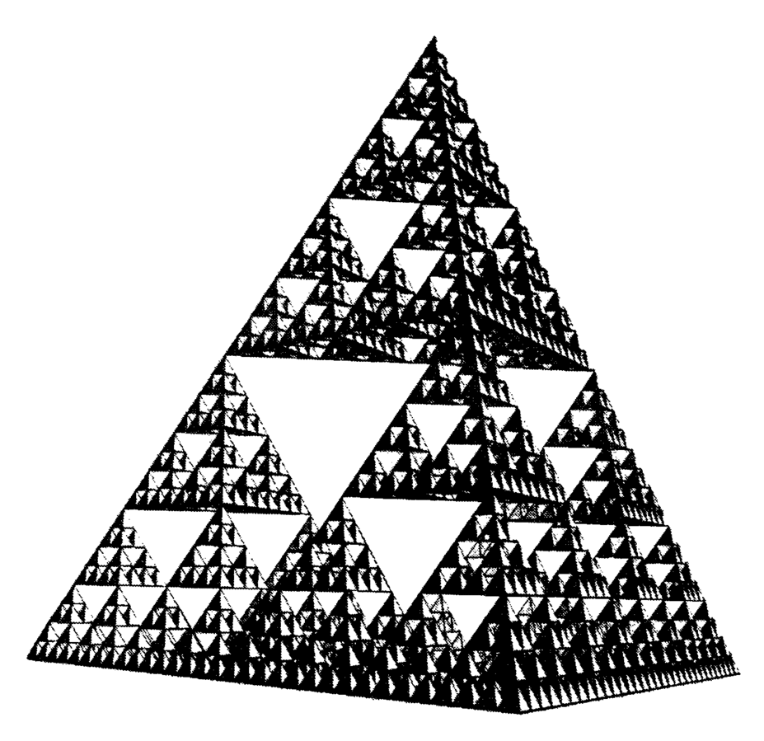
source: https://it.wikipedia.org/wiki/File:PyramideFractaleSmallInfini.GIF

Humboldt Math Festival 2018

