Humboldt
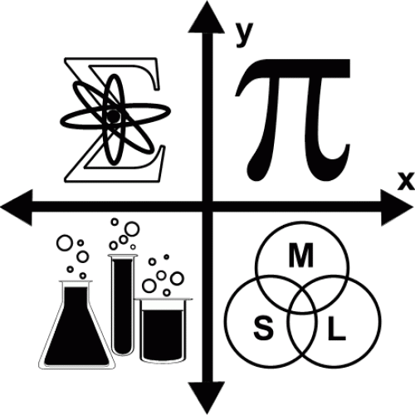
Math Festival
A Community Celebration of Math
Saturday April 27th
12:00 to 4:00
Adorni Center
1011 Waterfront Drive Eureka
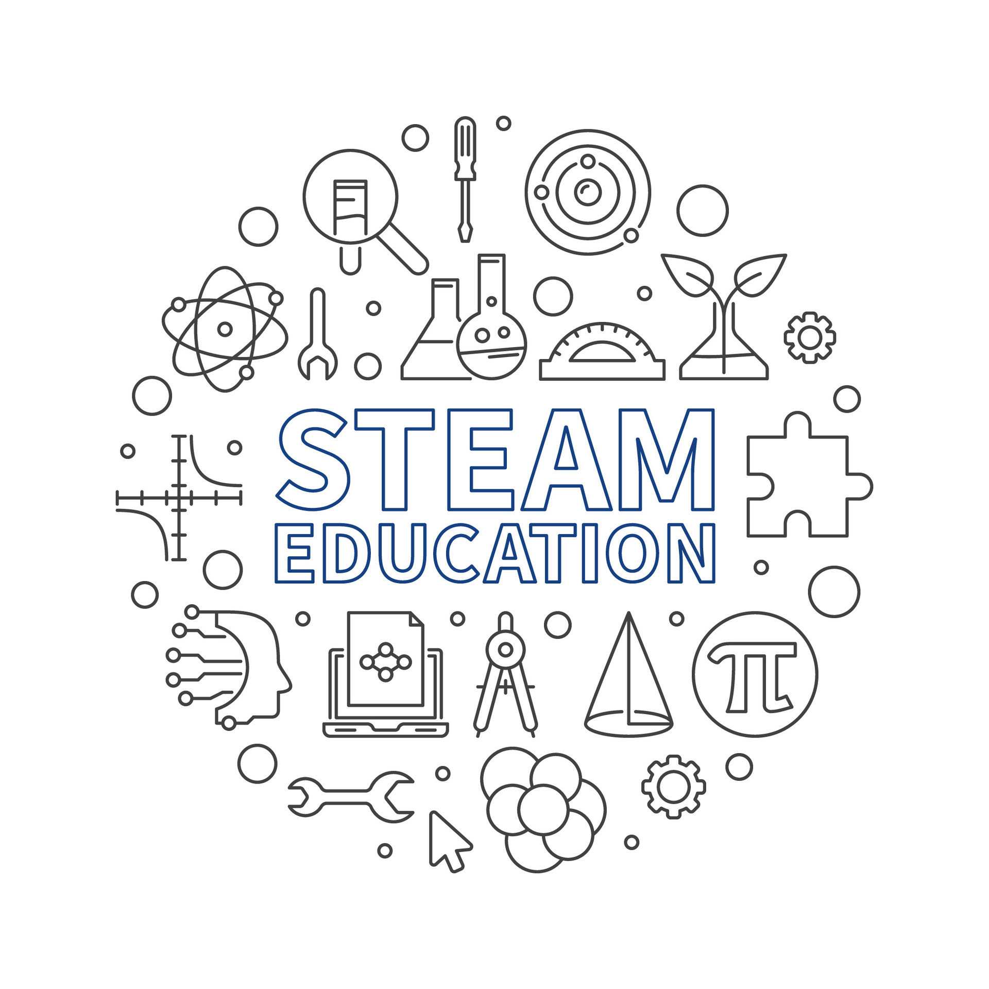

Free Admission
•Puzzles & Games
•Demonstrations
•Make-and-take
•Engineering Challenge
•Rubik’s Cube Activities
•Career & College Info
•Activities for all ages!

For More Information, contact
hmathfest@gmail.com (707)845-7465
or visit humboldtmathfestivial.weebly.com
Humb

